**MyGalileoApp** – an ecosystem of innovation

***Published:***

*17 December 2019*

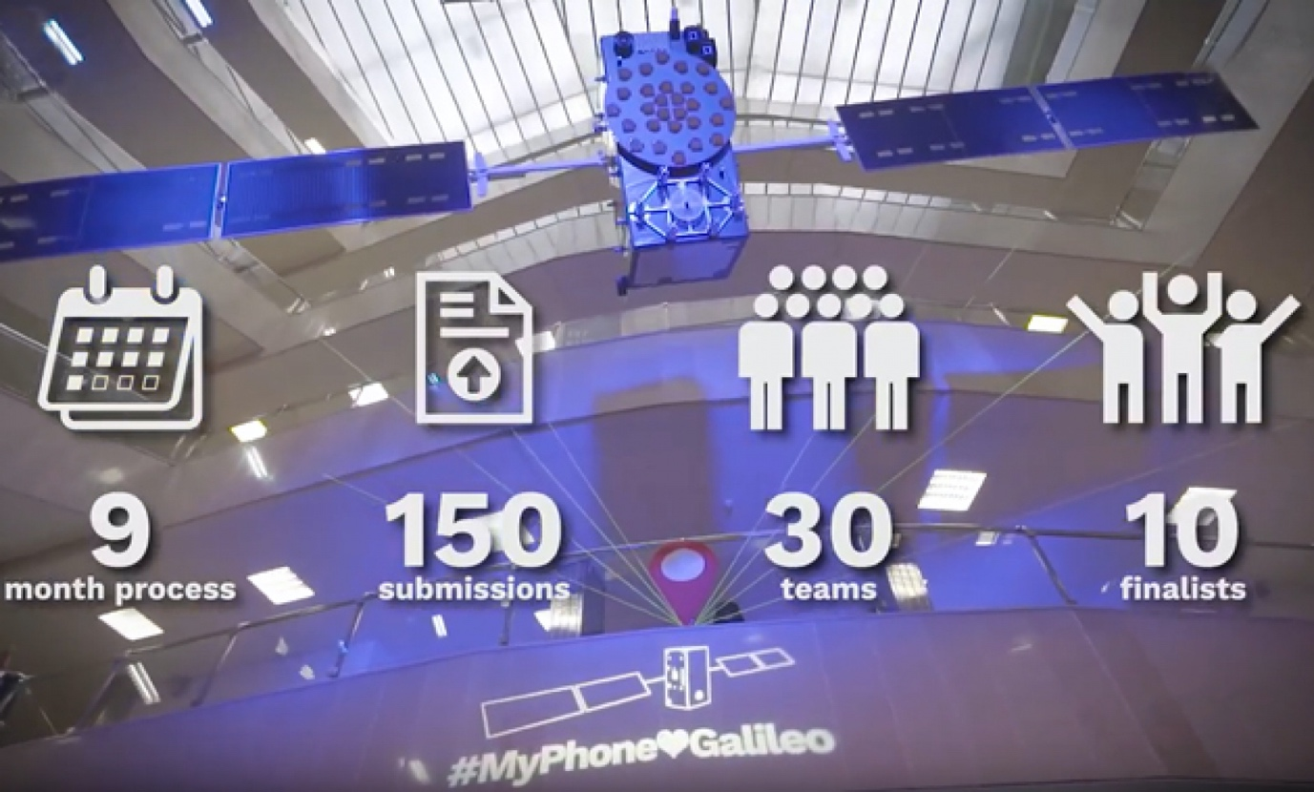

*MyGalileoApp competitors learned some of the key elements needed for a successful app*

**The**[**MyGalileoApp competition**](https://www.gsa.europa.eu/mygalileoapp)**has contributed to the creation of an ecosystem that helps start-ups and other innovators to build innovative applications and grow while enabling both private and public investors to find and invest in projects of interest to them. At the MyGalileoApp finals, which took place at the European GNSS Agency’s (GSA) Prague headquarters at the start of November, start-ups heard about some of the key elements that they will need to succeed in a highly-competitive marketplace.**

Galileo has been available to users around the globe since the launch of initial services back in December 2016 and the challenge generally, and for the MyGalileoApp competition specifically, is to make use of the Galileo services to develop systems and applications and to drive innovation based on the technology that Galileo makes available. The competition took nine months in total, during which the competitors progressed from the idea stage to creating a working app with 100% functionality.

**Engines of innovation**

Francesco Perticarari from Silicon Roundabout, who was a mentor at this year’s competition, noted that the approach of the GSA has been to leverage start-ups as engines of innovation. “The GSA did not just set up a competition to award money to successful developers, it set out to create an ecosystem of tech innovators, from start-ups to mentors and investors and the GSA itself, which also provides support,” he said, adding that the power of the MyGalileoApp competition is the ecosystem it creates that enables start-ups to deliver.

 “Whether or not you win a prize today, this is not the end of the story. The connections you have made with mentors, investors and other start-ups are what you should really treasure,” he told the finalists in this year’s competition.

**Watch this:** [Meet Argeo: #MyGalileoApp Competition Winner](https://www.youtube.com/watch?v=lQCNP0fXlJA&list=PLoW55g8cihhK5HNAvwiRsG9BL4aGQQBFE)

Another mentor, Piotr Bucki from Bucki PRO, outlined some of the forces that can drive a start-up forward, including social demographics in the form of a trend that an app can follow. It is also possible to ride a regulatory wave. “If rules from the European Commission or some other authority call for improvements in a service, then companies have no choice but to up their game, he said.

**Growth mind-set**

“In addition to timing, financing, strategy and riding the aforementioned waves, one more thing that makes start-ups successful is having a growth mind-set. A growth mind-set is the opposite of a fixed mind-set, in which intelligence is static, while in a growth mind-set intelligence and skills can be developed and iterated,” Bucki said.

Maaike Dokter from Xablu noted that location services can improve our quality of life, and that this was true for all of the sectors addressed by the MyGalileoApp finalists’ apps. As a designer with a focus on healthcare, she outlined how location-based services can improve things in this industry by optimising processes and reducing admin, allowing providers to focus on healthcare provision and reducing the amount of time a person has to spend in hospital.

“By increasing outdoor and indoor accuracy, we can take advantage of these opportunities. The MyGalileoApp competitors are finding solutions in which Galileo plays an important role, turning ideas into reality,” she said.

**Ensuring sustainability**

At a panel discussion held later in the day, start-ups heard from investors about the key qualities that would ensure their sustainability. Marketa Filipenska, International Funding Specialist at the South Moravian Innovation Centre (JIC) said that, in addition to mentoring, complementary services are also important, closely linked to the ecosystem in the region.

**Read this:** [EGNOS service for payment and liability-critical road applications](https://www.gsa.europa.eu/newsroom/news/invitation-tender-egnos-service-payment-and-liability-critical-road-applications)

 “We connect venture capital funds, business angels, universities, local stakeholders and corporates - all of these meet with our start-ups and clients to identify opportunities on the market. Investor matching is important, not only to make the business sustainable, but to scale up the company,” she said.

Marta Krywanis-Brzostowska, Head of Downstream R&D in the GSA Market Development Department, noted that when reviewing projects for funding, one thing at the forefront of the GSA’s mind is that it does not want another prototype to put on the shelf.

“We always highlight that it is important to have a link between the proposed solution and needs on the market. Knowledge of the market is critical, so we ask applicants to include a business plan along with their proposals,” she said, adding that an important tool in understanding the market is the [GSA’s GNSS Market Report](https://www.gsa.europa.eu/market/market-report).

“To be sustainable, you have to follow trends, be creative, understand the technology, be enthusiastic about what you are doing and be open to any support,” she said.

Thanks to MyGalileoApp, the GSA has built a network where business partners, public players and investors can connect with start-ups and young innovators, thereby contributing to the development of innovative applications leveraging the advantages of Galileo.